Udf

Logic used udf to filter the tweets by donald trump as shown and made a count

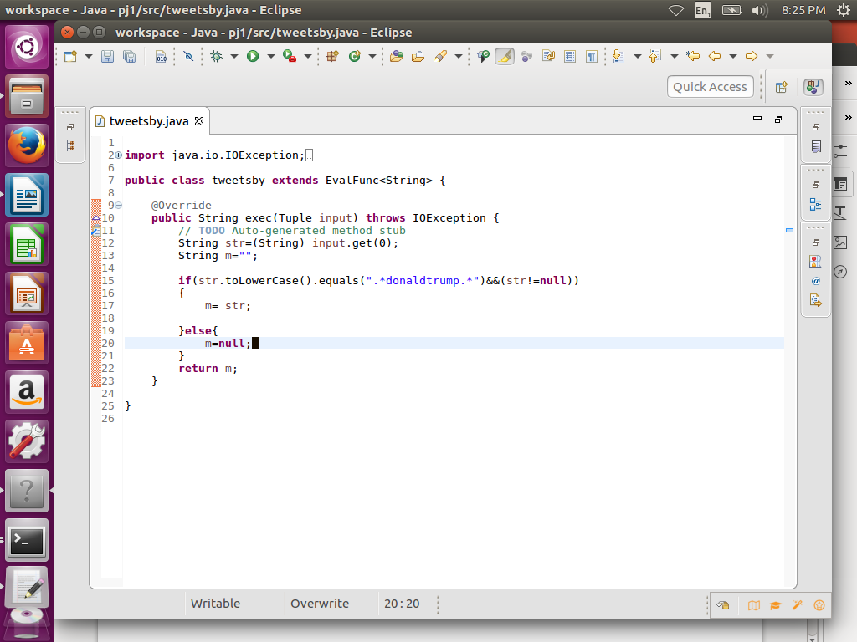

**PIG COMMANDS**

**LOGIC:-**load the data and then used tweetby function of udf (Step d) to filter tweets by trump

**STEP1:-REGISTER UDF**

**Step2:**load a using schema as shown

**Step3:foreach** A generating tweetsby(handle) which will perform filtration accoding to udf

**Step :**group by Donald trump and made a count

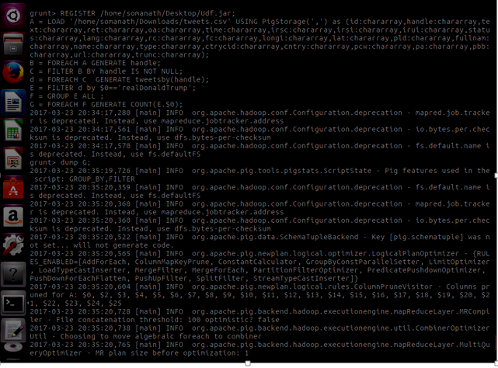

Output-

3218

